1. Instalar apache “yum install httpd”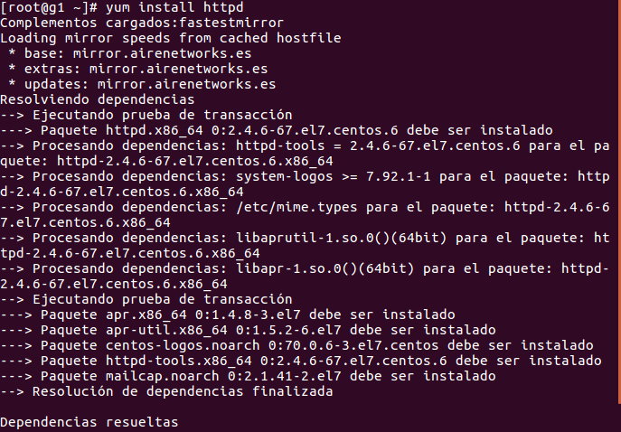
2. iniciarlo “systemctl start httpd.service”

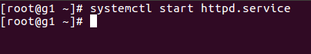

1. Comprobar el acceso

